254721 Analytical Dyanamics Project 2 Report

1. Problem 1
A particle of mass $m$ has an initial velocity $v_{0}$ along the horizontal rim of a smooth fixed hemispherical bowl of radius $r$ as shown in figure 1. Use the spherical coordinate system. Demonstrates the results for various cases of $v_{0}.$
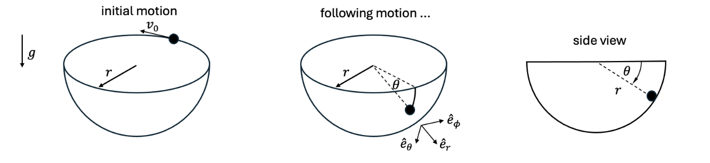
Figure 1 Dynamic system of Problem 1

1.1 Generalized Coordinates
A free particle in 3D space has 3-DOF of motion, in spherical coordinates are $\left(r, θ,ϕ\right)$, but in this problem the particle is stuck to the surface of the hemispherical bowl $\left(r=constant\right)$ then DOF of this system will be reduced to 2 are angle down from the vertical ($θ$) and angle around the vertical axis ($ϕ$). So, we can write generalized coordinate, $q_{i}$ is a set of $\left\{θ, ϕ\right\}$
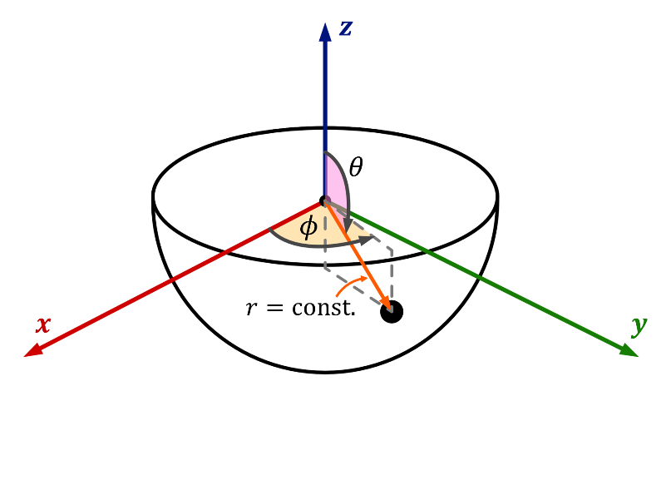
Figure 1 Generalized coordinate of system in problem 1

1.2 Kinematics
From kinematics of particle in spherical coordinate, position vector is given by:
 | $$r=re_{r}$$ | (1)
Differentiating with respect to time we will obtain velocity vector as shown. Note that radius, $r$ is constant, the derivative of this term will be zero.
 | $$v=\dot{r}=\dot{r}e_{r}+r{\dot{e}}_{r}$$  $$v= r{\dot{e}}_{r}$$ | (2)
We will find ${\dot{e}}_{r}$ from total rotation rate of the unit vector triad is given by
 | $$ω=\dot{θ}e_{ϕ}+\dot{ϕ}e_{z} where: e_{z}=\cos{θ}e_{r}-\sin{θ}e_{θ}$$  $$ω=\dot{ϕ}\cos{θ}e_{r}-\dot{ϕ}\sin{θ}e_{θ}+\dot{θ}e_{ϕ}$$ | (3)
Then ${\dot{e}}_{r}$ can be derived from:
$${\dot{e}}_{r}=ω×e_{r}=\left|\begin{matrix}e_{r} & e_{θ} & e_{ϕ} \\ \dot{ϕ}\cos{θ} & -\dot{ϕ}\sin{θ} & \dot{θ} \\ 1 & 0 & 0\end{matrix}\right|$$  $${\dot{e}}_{r}=\dot{θ}e_{θ}+\dot{ϕ}\sin{θ}e_{ϕ}$$ | (4)
Now we get velocity vector is:
$$\boxed{v=r\dot{θ}e_{θ}+r\dot{ϕ}\sin{θ}e_{ϕ}}$$ | (5)
And then sum square it, we get velocity squared of this particle:
$$v^{2}={\left(r\dot{θ}\right)}^{2}+{\left(r\dot{ϕ}\sin{θ}\right)}^{2}$$  $$\boxed{v^{2}=r^{2}\left({\dot{θ}}^{2}+{\dot{ϕ}}^{2}\sin^{2}{θ}\right)}$$ | (6)

1.3 Kinetic Energy
The kinetic energy ($T$) of this system is:
$$T=\frac{1}{2}mv^{2}$$  $$\boxed{T=\frac{1}{2}mr^{2}\left({\dot{θ}}^{2}+{\dot{ϕ}}^{2}\sin^{2}{θ}\right)}$$ | (7)

1.4 Potential Energy
In Figure 2, we set the z-axis upwards. The position of the particle along the z-axis is given by standard spherical conversion is:
$$z=r\cos{θ}$$ | (8)
Since gravity acts downwards (negative z-dir.), the potential energy is:
$$\boxed{V=mgz=mgr\cos{θ}}$$ | (9)

1.5 Lagrange’s Equations
The generalize coordinate $(q_{i})$ are $q_{1}=θ$ and $q_{2}=ϕ$. The standard form of Lagrangian equation can be derived by:
$$\boxed{L=T-V=\frac{1}{2}mr^{2}\left({\dot{θ}}^{2}+{\dot{ϕ}}^{2}\sin^{2}{θ}\right)-mgr\cos{θ}}$$ | (10)
$$\frac{d}{dt}\left(\frac{∂L}{∂{\dot{q}}_{i}}\right)-\left(\frac{∂L}{∂q_{i}}\right)=0 ;i=1, 2$$ | (11)
For $q_{1}=θ$, Lagrange’s equation components of this coordinate as shown:
$$\frac{∂L}{∂θ}=\frac{∂}{∂θ}\left(\frac{1}{2}mr^{2}\left({\dot{θ}}^{2}+{\dot{ϕ}}^{2}\sin^{2}{θ}\right)-mgr\cos{θ}\right)$$  $$\frac{∂L}{∂θ}=\frac{∂}{∂θ}\left(\frac{1}{2}mr^{2}{\dot{θ}}^{2}+\frac{1}{2}mr^{2}{\dot{ϕ}}^{2}\sin^{2}{θ}-mgr\cos{θ}\right)$$  $$\frac{∂L}{∂θ}=0+\frac{1}{2}mr^{2}\left(2{\dot{ϕ}}^{2}\sin{θ}\cos{θ}\right)+mgr\sin{θ}$$  $$\boxed{\frac{∂L}{∂θ}=mr^{2}{\dot{ϕ}}^{2}\sin{θ}\cos{θ}+mgr\sin{θ}}$$ | (12)
$$\frac{∂L}{∂\dot{θ}}=\frac{∂}{∂\dot{θ}}\left(\frac{1}{2}mr^{2}\left({\dot{θ}}^{2}+{\dot{ϕ}}^{2}\sin^{2}{θ}\right)-mgr\cos{θ}\right)$$  $$\frac{∂L}{∂\dot{θ}}=\frac{∂}{∂\dot{θ}}\left(\frac{1}{2}mr^{2}{\dot{θ}}^{2}+\frac{1}{2}mr^{2}{\dot{ϕ}}^{2}\sin^{2}{θ}-mgr\cos{θ}\right)$$  $$\frac{∂L}{∂\dot{θ}}=mr^{2}\dot{θ}$$  $$\frac{d}{dt}\left(\frac{∂L}{∂\dot{θ}}\right)=\frac{d}{dt}\left(mr^{2}\dot{θ}\right)$$  $$\boxed{\frac{d}{dt}\left(\frac{∂L}{∂\dot{θ}}\right)=mr^{2}\ddot{θ}}$$ | (13)
The Lagrange’s EOM of $q_{1}=θ$ is:
$$\frac{d}{dt}\left(\frac{∂L}{∂\dot{θ}}\right)-\left(\frac{∂L}{∂θ}\right)=0$$  $$mr^{2}\ddot{θ}-\left(mr^{2}{\dot{ϕ}}^{2}\sin{θ}\cos{θ}+mgr\sin{θ}\right)=0$$  $$mr^{2}\left(\ddot{θ}-{\dot{ϕ}}^{2}\sin{θ}\cos{θ}-\frac{g}{r}\sin{θ}\right)=0$$  $$\boxed{\ddot{θ}-{\dot{ϕ}}^{2}\sin{θ}\cos{θ}-\frac{g}{r}\sin{θ}=0}$$ | (14)
For $q_{2}=ϕ$, Lagrange’s equation components of this coordinate as shown:
$$\frac{∂L}{∂ϕ}=\frac{∂}{∂ϕ}\left(\frac{1}{2}mr^{2}\left({\dot{θ}}^{2}+{\dot{ϕ}}^{2}\sin^{2}{θ}\right)-mgr\cos{θ}\right)$$  $$\boxed{\frac{∂L}{∂ϕ}=0}$$ | (15)
$$\frac{∂L}{∂\dot{ϕ}}=\frac{∂}{∂\dot{ϕ}}\left(\frac{1}{2}mr^{2}\left({\dot{θ}}^{2}+{\dot{ϕ}}^{2}\sin^{2}{θ}\right)-mgr\cos{θ}\right)$$  $$\frac{∂L}{∂\dot{ϕ}}=\frac{∂}{∂\dot{ϕ}}\left(\frac{1}{2}mr^{2}{\dot{θ}}^{2}+\frac{1}{2}mr^{2}{\dot{ϕ}}^{2}\sin^{2}{θ}-mgr\cos{θ}\right)$$  $$\frac{∂L}{∂\dot{ϕ}}=mr^{2}\dot{ϕ}\sin^{2}{θ}$$  $$\boxed{\frac{d}{dt}\left(\frac{∂L}{∂\dot{ϕ}}\right)=\frac{d}{dt}\left(mr^{2}\dot{ϕ}\sin^{2}{θ}\right)}$$ | (16)
The Lagrange’s EOM of $q_{2}=ϕ$ is:
$$\frac{d}{dt}\left(\frac{∂L}{∂\dot{ϕ}}\right)-\frac{∂L}{∂ϕ}=0$$  $$\frac{d}{dt}\left(mr^{2}\dot{ϕ}\sin^{2}{θ}\right)=0$$  $$\int{\frac{d}{dt}\left(mr^{2}\dot{ϕ}\sin^{2}{θ}\right)}dt=\int{0}dt$$  $$\boxed{mr^{2}\dot{ϕ}\sin^{2}{θ}=C=constant}$$ | (17)
This derivation implies that angular momentum is conserved. For solve this constant, $C$ we need to use initial condition is at $t=0$, the particle is at the rim $\left(θ=π/2\right)$ with linear velocity $v_{0}$ that tangent around z-axis, so we can transform this linear velocity to angular velocity as shown
$$v=ω×r$$  $$v_{0}=\dot{ϕ}r or \dot{ϕ}=\frac{v_{0}}{r}$$ | (18)
Apply these conditions to equation (17) then we get constant, $C$ is:
$$mr^{2}\left(\frac{v_{0}}{r}\right)\sin^{2}\left(\frac{π}{2}\right)=C$$  $$\boxed{C=mrv_{0}}$$ | (19)
Substitute equation (19) back to equation (17) then we get:
$$mr^{2}\dot{ϕ}\sin^{2}{θ}=mrv_{0}$$  $$\dot{ϕ}=\frac{mrv_{0}}{mr^{2}\sin^{2}{θ}}$$  $$\boxed{\dot{ϕ}=\frac{v_{0}}{r\sin^{2}{θ}}}$$ | (20)
Substitute equation (20) back to equation (14) then we get final equation of motion as shown:
$$\ddot{θ}-{\left(\frac{v_{0}}{r\sin^{2}{θ}}\right)}^{2}\sin{θ}\cos{θ}-\frac{g}{r}\sin{θ}=0$$  $$\ddot{θ}-\frac{v_{0}^{2}}{r^{2}\sin^{3}{θ}}\cos{θ}-\frac{g}{r}\sin{θ}=0$$  $$\boxed{\ddot{θ}=\frac{v_{0}^{2}}{r^{2}\sin^{3}{θ}}\cos{θ}+\frac{g}{r}\sin{θ}}$$ | (21)
Where the first term represents the effect of initial velocity, which causes the particle to experience centrifugal force, and the second term represents the effect of gravity, which causes the particle to fall to the bottom of the bowl.

1.6 Numerical Simulation Case and Result
We will model the obtained Lagrange’s EOM in equation (21) by using Python, employing the scipy (ODEint) library to solve the ODE. Initially, we will set all parameters to 1, resulting in graphs showing the relationship between angular velocity $\left(\dot{θ}\right)$ and time, and angular displacement $\left(θ\right)$ and time as shown in Figure 2, and a graph showing the particle's trajectory as shown in Figure 3.
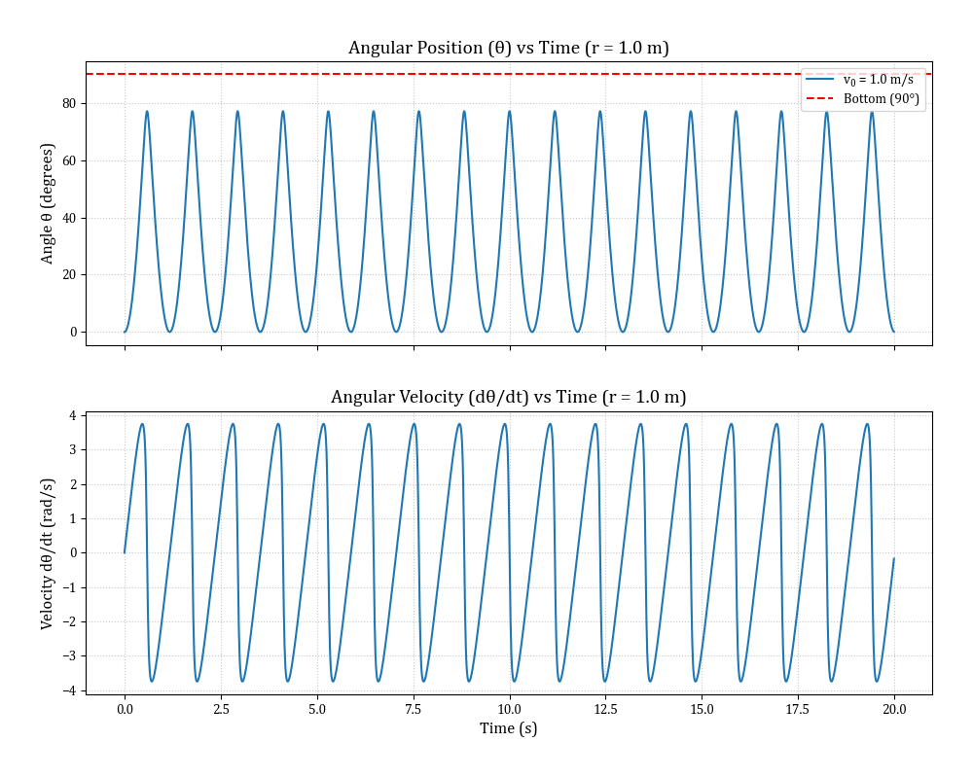
Figure 2 Relationship of angular velocity $\left(\dot{θ}\right)$ and angular displacement $\left(θ\right)$ versus time when all parameters are set to 1
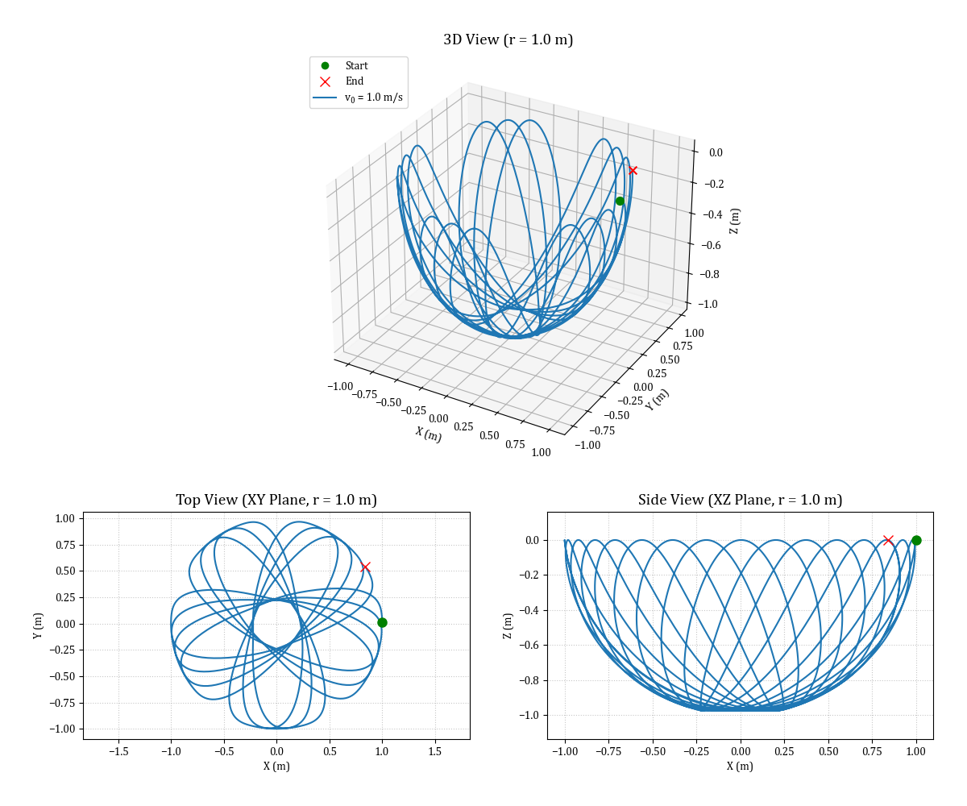
Figure 3 Trajectory of particle when all parameters are set to 1
CASE 1) The effect of the initial velocity $\left(v_{0}\right)$
In this case we will fix the bowl radius and vary initial velocity:
- Fixed $r=1.0 m$
- Vary $v_{0}=\left[\begin{matrix}1.0 & 2.5 & 5.0 & 7.5 & 10.0\end{matrix}\right] m/s$
The results are shown in Figure 4 and 5. As the initial velocity increases, the maximum depth that the particle reaches decreases significantly. The particle oscillates with a higher frequency and stays closer to the rim.
The centrifugal force term in the governing equation scales with the square of the initial velocity $(v_{0}^{2})$. At higher velocities, the particle possesses more angular momentum. This creates a strong centrifugal force against the wall of the bowl, perfectly counteracting the downward pull of gravity much earlier in the descent, creating a stable, shallow orbit.
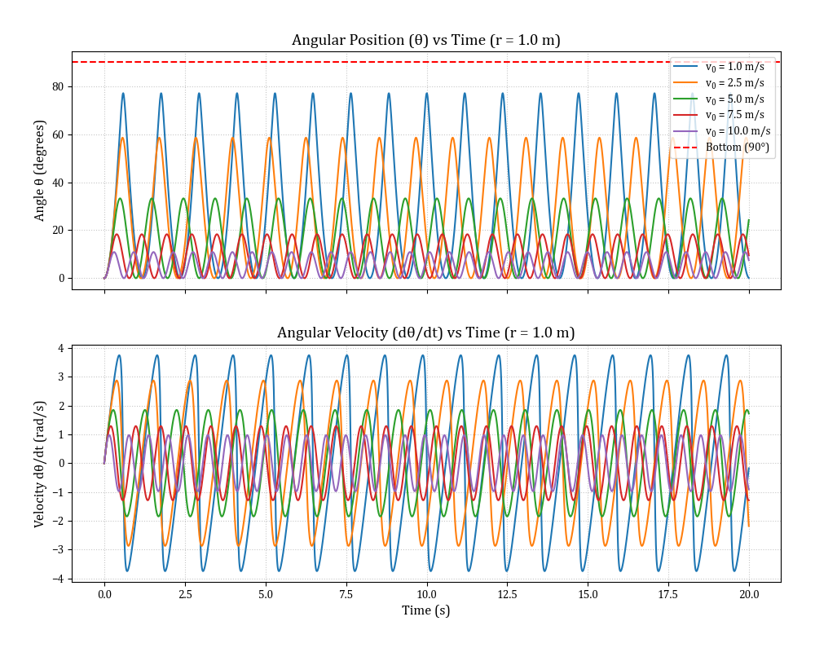
Figure 4 Relationship of angular velocity $\left(\dot{θ}\right)$ and angular displacement $\left(θ\right)$ versus time in case 1: the effect of the initial velocity
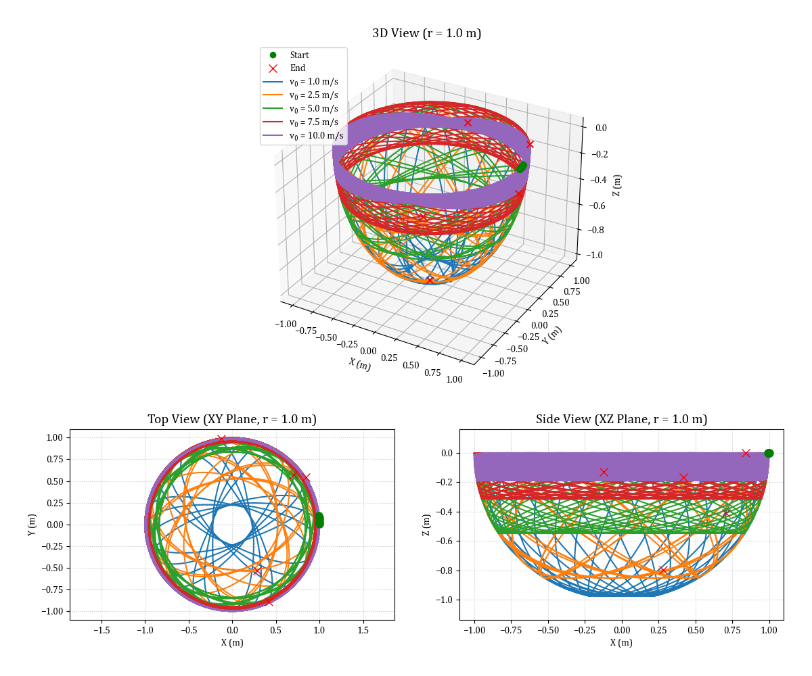
Figure 5 Trajectory of each particle in case 1: the effect of the initial velocity
CASE 2) The effect of the bowl radius $\left(r\right)$
In this case we will fix initial velocity and vary bowl radius:
- Fixed $v_{0}=5.0 m/s$
- Vary $r=\left[\begin{matrix}0.5 & 1.0 & 1.5 & 2.0\end{matrix}\right] m$
The results are shown in Figure 6 and 7. For a fixed initial velocity, increasing the bowl's radius causes the particle to plunge much deeper into the bowl. In contrast, a smaller radius keeps the particle moving near the rim.
The gravitational acceleration along the slope scales inversely with the radius $\left(1/r\right)$, whereas the centrifugal acceleration scales inversely with the square of the radius $\left(1/{r^{2}}\right)$,. Therefore, as the bowl gets larger, the centrifugal force decays much faster than the effect of gravity. In a larger bowl, a velocity of 5.0 m/s is no longer sufficient to maintain a high orbit, and gravity dominates.
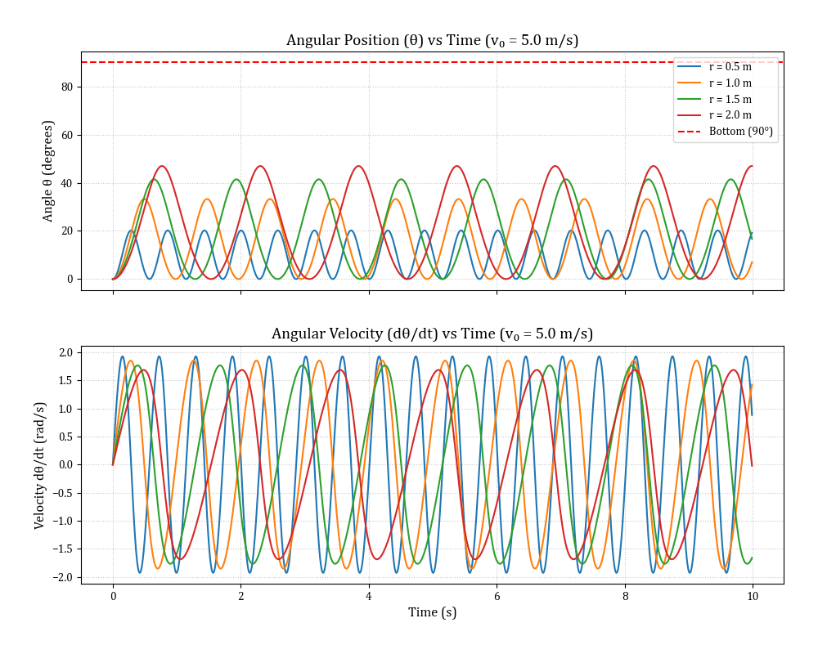
Figure 6 Relationship of angular velocity $\left(\dot{θ}\right)$ and angular displacement $\left(θ\right)$ versus time in case 2: the effect of the bowl radius
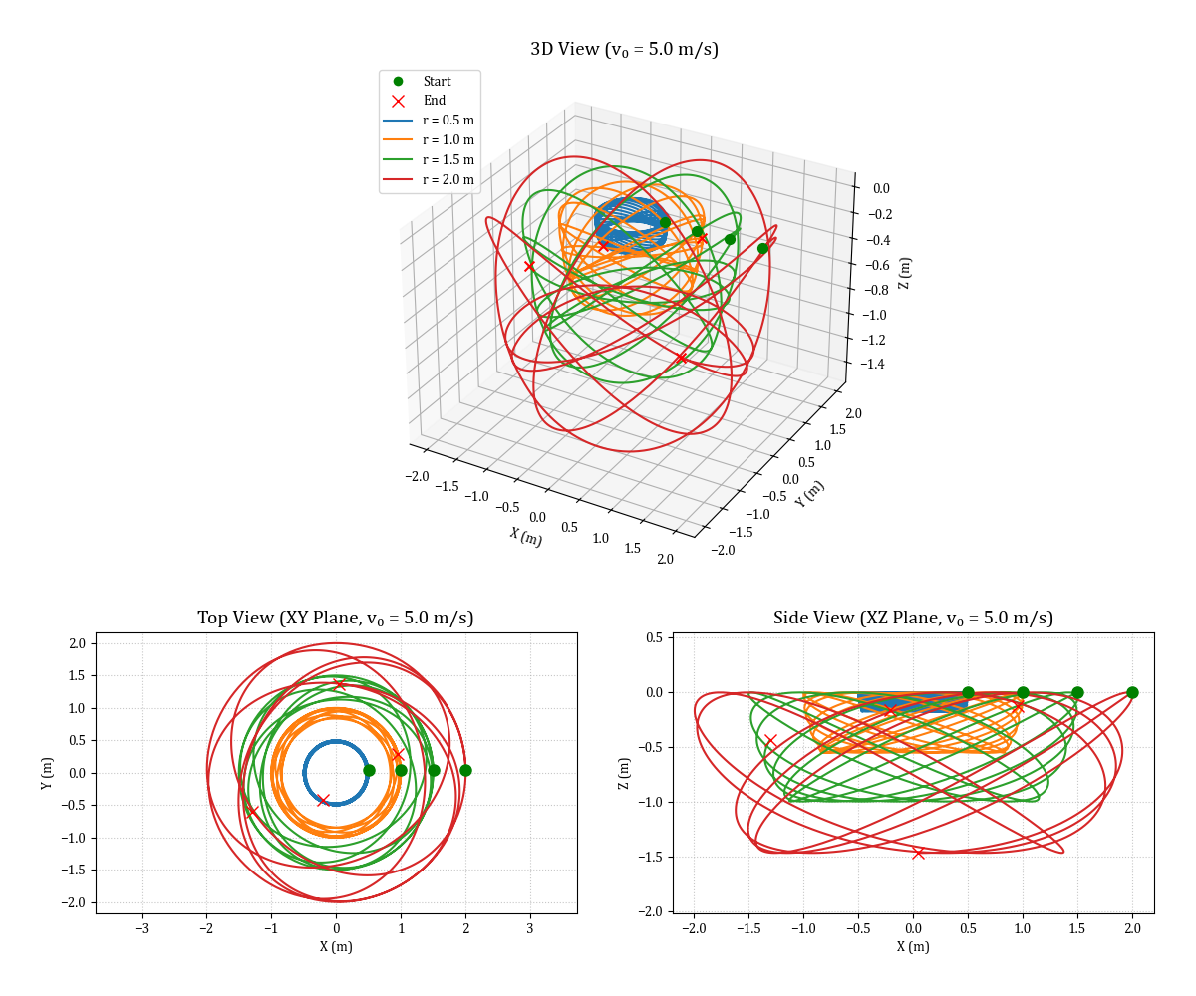
Figure 7 Trajectory of each particle in case 2: the effect of the bowl radius

2. Problem 2
Particles A and B are connected by a massless, inextensible cord which goes around a massless pulley$.$
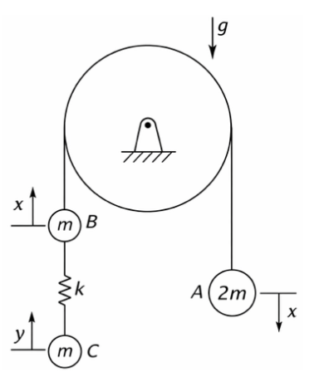
Figure 8 Dynamic system of Problem 2

2.1 Generalized Coordinates
Since mass A and mass B are connected by an inextensible cord that goes over a pulley. Therefore, their motions are not independent. If mass B moves up by a distance $x$, mass A must move down by the same distance $x$. The position of both masses can be described by a single variable, $x$.
However, mass C is connected to mass B by a spring. Spring can stretch or compress, meaning the position of mass C is not rigidly tied to the position of mass B. Therefore, let another independent variable that describe vertical displacement of mass C is $y$.
Based on the above, this system has 2-DOF of motion, are vertical displacement of mass A and B ($x$) and vertical displacement of mass C ($y$). So, we can write generalized coordinate, $q_{i}$ is a set of $\left\{x, y\right\}$

2.2 Kinematics
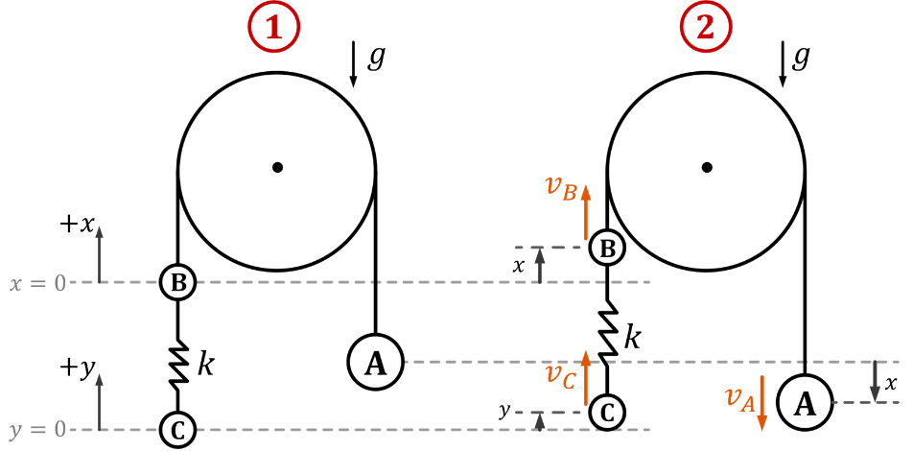
Figure 9 Generalized coordinate of system in problem 1
From kinematics diagram as shown in Figure 9. The velocities of the masses are given by:
 | $$v_{A}=-\dot{x}$$ | (1)
 | $$v_{B}=\dot{x}$$ | (2)
 | $$v_{C}=\dot{y}$$ | (3)
And then sum square it, we get velocity squared of each mass:
$$v_{A}^{2}=v_{B}^{2}={\dot{x}}^{2}$$ | (4)
$$v_{C}^{2}={\dot{y}}^{2}$$ | (5)

2.3 Kinetic Energy
The total kinetic energy is the sum of the kinetic energy of each mass is:
$$T=\frac{1}{2}m_{A}v_{A}^{2}+\frac{1}{2}m_{B}v_{B}^{2}+\frac{1}{2}m_{C}v_{C}^{2}$$  $$T=\frac{1}{2}\left(2m\right){\dot{x}}^{2}+\frac{1}{2}\left(m\right){\dot{x}}^{2}+\frac{1}{2}\left(m\right){\dot{y}}^{2}$$  $$\boxed{T=\frac{3}{2}m{\dot{x}}^{2}+\frac{1}{2}m{\dot{y}}^{2}}$$ | (6)

2.4 Potential Energy
In static equilibrium, the changes in gravitational potential energy and the linear term in the spring's elastic potential energy cancel each other out.
But when it moves, if mass B moves up by $x$, the spring stretches by $x$. If mass C moves up by $y$, the spring compresses by $y$. The net change in length from equilibrium is $\left(x-y\right)$. The total potential energy is:
$$\boxed{V=\frac{1}{2}k{\left(x-y\right)}^{2}}$$ | (7)

2.5 Lagrange’s Equations
The generalize coordinate $(q_{i})$ are $q_{1}=x$ and $q_{2}=y$. The standard form of Lagrangian equation can be derived by:
$$L=T-V=\frac{3}{2}m{\dot{x}}^{2}+\frac{1}{2}m{\dot{y}}^{2}-\frac{1}{2}k{\left(x-y\right)}^{2}$$  $$\boxed{L=T-V=\frac{3}{2}m{\dot{x}}^{2}+\frac{1}{2}m{\dot{y}}^{2}-\frac{1}{2}kx^{2}+kxy-\frac{1}{2}ky^{2}}$$ | (8)
$$\frac{d}{dt}\left(\frac{∂L}{∂{\dot{q}}_{i}}\right)-\left(\frac{∂L}{∂q_{i}}\right)=0 ;i=1, 2$$ | (9)
For $q_{1}=x$, Lagrange’s equation components of this coordinate as shown:
$$\frac{∂L}{∂x}=\frac{∂}{∂x}\left(\frac{3}{2}m{\dot{x}}^{2}+\frac{1}{2}m{\dot{y}}^{2}-\frac{1}{2}kx^{2}+kxy-\frac{1}{2}ky^{2}\right)$$  $$\boxed{\frac{∂L}{∂x}=-kx+ky}$$ | (10)
$$\frac{∂L}{∂\dot{x}}=\frac{∂}{∂\dot{x}}\left(\frac{3}{2}m{\dot{x}}^{2}+\frac{1}{2}m{\dot{y}}^{2}-\frac{1}{2}kx^{2}+kxy-\frac{1}{2}ky^{2}\right)$$  $$\frac{∂L}{∂\dot{x}}=3m\dot{x}$$  $$\frac{d}{dt}\left(\frac{∂L}{∂\dot{x}}\right)=\frac{d}{dt}\left(3m\dot{x}\right)$$  $$\boxed{\frac{d}{dt}\left(\frac{∂L}{∂\dot{x}}\right)=3m\ddot{x}}$$ | (11)
The Lagrange’s EOM of $q_{1}=x$ is:
$$\frac{d}{dt}\left(\frac{∂L}{∂\dot{x}}\right)-\left(\frac{∂L}{∂x}\right)=0$$  $$3m\ddot{x}-\left(-kx+ky\right)=0$$  $$\boxed{3m\ddot{x}+k\left(x-y\right)=0}$$ | (12)
For $q_{2}=y$, Lagrange’s equation components of this coordinate as shown:
$$\frac{∂L}{∂y}=\frac{∂}{∂y}\left(\frac{3}{2}m{\dot{x}}^{2}+\frac{1}{2}m{\dot{y}}^{2}-\frac{1}{2}kx^{2}+kxy-\frac{1}{2}ky^{2}\right)$$  $$\boxed{\frac{∂L}{∂y}=kx-ky}$$ | (13)
$$\frac{∂L}{∂\dot{y}}=\frac{∂}{∂\dot{y}}\left(\frac{3}{2}m{\dot{x}}^{2}+\frac{1}{2}m{\dot{y}}^{2}-\frac{1}{2}kx^{2}+kxy-\frac{1}{2}ky^{2}\right)$$  $$\frac{∂L}{∂\dot{y}}=m\dot{y}$$  $$\boxed{\frac{d}{dt}\left(\frac{∂L}{∂\dot{y}}\right)=m\ddot{y}}$$ | (14)
The Lagrange’s EOM of $q_{2}=y$ is:
$$\frac{d}{dt}\left(\frac{∂L}{∂\dot{y}}\right)-\frac{∂L}{∂y}=0$$  $$m\ddot{y}-\left(kx-ky\right)=0$$  $$\boxed{m\ddot{y}-k\left(x-y\right)=0}$$ | (15)
To solve Lagrange’s EOM of this problem, we need to convert both of Lagrange’s EOM to state-space form. We start with the two equations of motion we derived in equation (12) and (15), solved for acceleration we get:
$$\ddot{x}=-\frac{k}{3m}\left(x-y\right)$$ | (16)
$$\ddot{y}=\frac{k}{m}\left(x-y\right)$$ | (17)
Let's define four state variables:
$$S_{1}=x$$  $$S_{2}=\dot{x}$$  $$S_{3}=y$$  $$S_{4}=\dot{y}$$ | (17)
Then we take the time derivative of each of these state variables to create our four new first-order equations:
$${\dot{S}}_{1}=\dot{x}=S_{2}$$  $${\dot{S}}_{2}=\ddot{x}=-\frac{k}{3m}\left(x-y\right)$$  $${\dot{S}}_{3}=\dot{y}=S_{4}$$  $${\dot{S}}_{4}=\ddot{y}=\frac{k}{m}\left(x-y\right)$$ | (17)

2.6 Numerical Simulation Case and Result
We will model the obtained Lagrange’s EOM in state-space form by using Python, employing the scipy (solve_ivp) library to solve initial value problem. Initially, we will set parameters of mass to 1 kg $\left(m=1\right)$ and spring stiffness to 10 N/m $\left(k=10\right)$and initial conditions are:
- Mass B starts at equilibrium, $x\left(0\right)=0 m$
- Mass B starts from rest, $\dot{x}\left(0\right)=0 m/s$
- Mass C is pulled down 0.1 meters, $y\left(0\right)=-0.1 m$
- Mass C starts from rest, $\dot{y}\left(0\right)=0 m/s$
The results are shown in Figure 10.
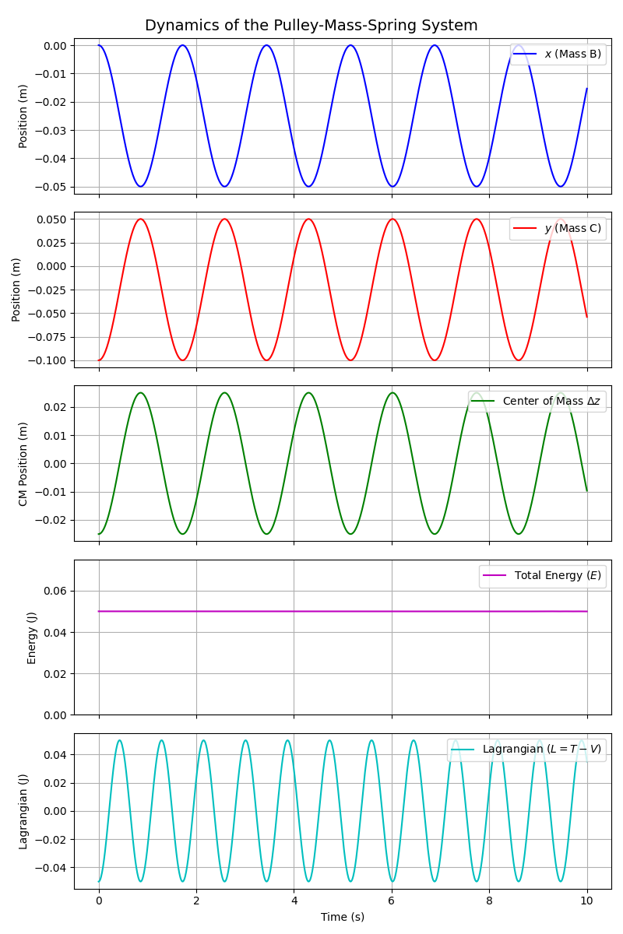
Figure 10 The graph shows the results from the simulation when mass is 1 kg, Spring stiffness is10 N/m and Mass C is pulled down 0.1 meters

The plots for $x$ and $y$ show pure sinusoidal oscillations that are out of phase (180° phase difference). The period of one full oscillation is approximately 1.72 seconds. This aligns perfectly with the analytical natural frequency for this coupled system, calculated as $ω_{n}=\sqrt{4k/3m}=\sqrt{40/3}=3.65$ rad/s.
The center of mass position $(∆z$) oscillates evenly between -0.025 m and +0.025 m. It does not remain stationary because the tension in the main cord over the fixed pulley fluctuates as the masses accelerate, creating a varying external reaction force on the system as a whole.
The total energy plot is a perfectly flat line at 0.05 Joules. We can verify this analytically that at $t=0$, kinetic energy is 0, and potential energy is $V=\frac{1}{2}k{\left(x\left(0\right)-y\left(0\right)\right)}^{2}=\frac{1}{2}\left(10\right){\left(0-\left(-0.1\right)\right)}^{2}=0.05 J$.
The Lagrangian $\left(L=T-V\right)$ oscillates smoothly between -0.05 J and +0.05 J. At the exact moments the system comes to a brief rest, $T=0$, so $L=-0.05 J$. When the masses pass through their relative center points (spring is relaxed), potential energy$V=0$, and the Lagrangian equals the peak kinetic energy of +0.05 J.

CASE 1) Rigid Body Drift
In this case we will set up initial conditions below:
- $x\left(0\right)=0.1 m$ $y\left(0\right)=0.1 m$
- $\dot{x}\left(0\right)=0.01 m/s$ $\dot{y}\left(0\right)=0.01 m/s$
The results are shown in Figure 11. The position plots for $x$ and $y$ display identical linear trajectories with a constant slope. The total energy remains constant and is composed entirely of kinetic energy. Because the relative displacement remains zero $(x-y=0)$, the spring force is never engaged. The system behaves as a single mass moving at a constant velocity, confirming the presence of a neutrally stable rigid-body mode due to the balanced static masses.
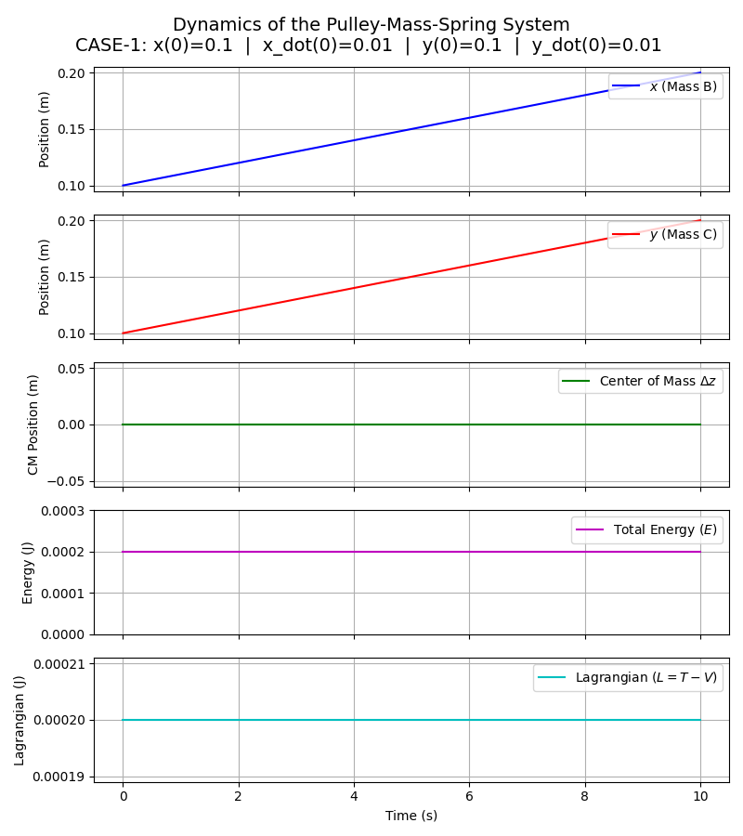
Figure 11 The graph shows the results from the simulation of CASE 1

CASE 2) Transient Response to Kinetic Impulse
In this case we will set up initial conditions below:
- $x\left(0\right)=0 m$ $y\left(0\right)=0 m$
- $\dot{x}\left(0\right)=0 m/s$ $\dot{y}\left(0\right)=1.0 m/s$
The results are shown in Figure 12. The plots show complex, coupled oscillations for both coordinates. Mass C moves initially, followed by a delayed oscillatory response from Mass B. This demonstrates the transient coupling effect of spring. The initial kinetic energy injected into Mass C is transferred into elastic potential energy, which then drives Mass B, causing energy to continuously transfer back and forth between the two degrees of freedom.
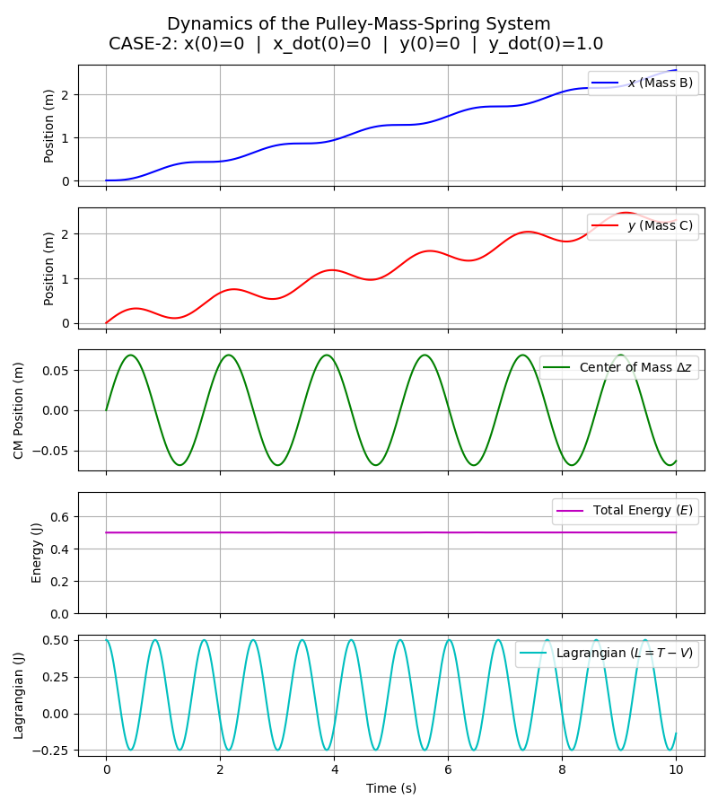
Figure 12 The graph shows the results from the simulation of CASE 2
CASE 3) The High Stiffness Spring
In this case we will increase spring stiffness from 10 N/m to 1,000 N/m and then set up initial conditions below:
- $x\left(0\right)=0 m$ $y\left(0\right)=-0.1 m$
- $\dot{x}\left(0\right)=0 m/s$ $\dot{y}\left(0\right)=0 m/s$
The results are shown in Figure 13 and 14. The position plots of $x$ and $y$ tightly overlap, tracking almost the exact same macroscopic trajectory while exhibiting very low-amplitude, high-frequency chatter. As stiffness becomes very large, spring acts increasingly like a rigid link. The 2-DOF system physically approaches a 1-DOF system, and the numerical solver correctly handles this stiff equation scenario by forcing the two masses to move in unison.
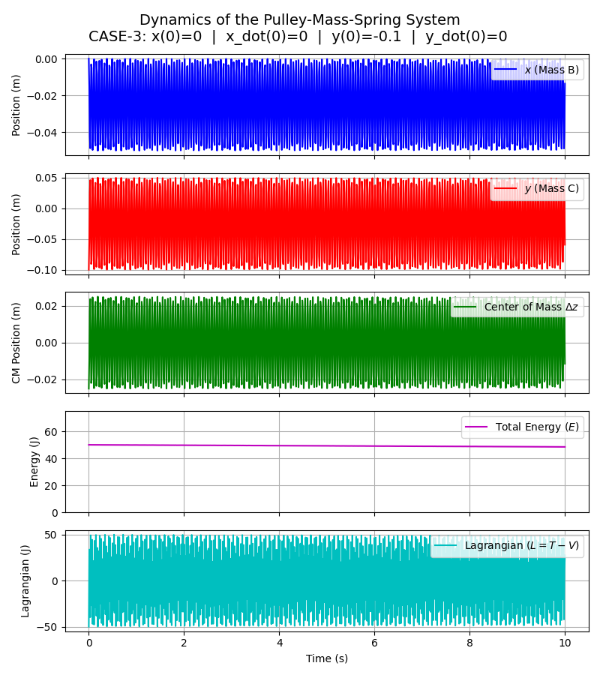
Figure 13 The graph shows the results from the simulation of CASE 3
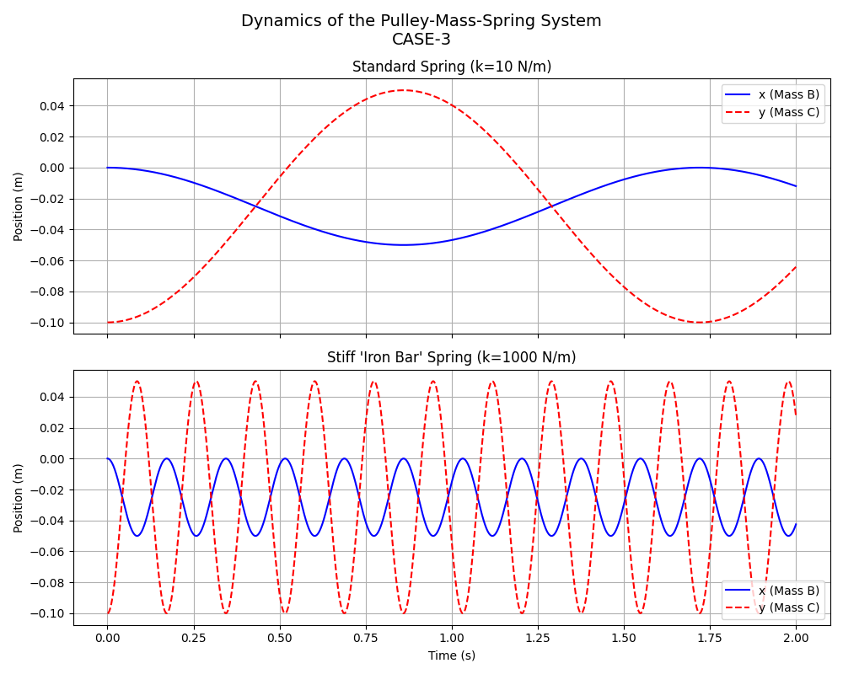
Figure 14 The graph compares the motion of each mass between springs with high and low stiffness.

